

EPIC Project Handover

Handover documents and details

Mediani | Rachael Low | Nurul Suhailah | Oon Yi Jing | Yeo Xiu Wen

26th Nov 2018

Contents

Project Handover 3

Technologies Used 3

Client-Side Applications 3

Server-Side Application 3

Development Language 3

Database 3

Integrated Development Environment 3

Respository 3

Architecture Diagram 4

Deployment Platform 4

Amazon Web Service Deployment Platform 5

GoDaddy Deployment Platform 5

Git Repository 6

Database 6

Users 6

Students, Graduates, Working Adults 6

EPIC Adminstrators 7

EPIC Service Partners 7

User Guide 7

Primary Users 7

Creating an Account 7

Signing up for a Study Trip 9

Signing up for an Internship 14

Secondary Users – ADMINS 17

Log in as an admin 17

Managing Study Trips 18

Managing Internships 21

Managing Users 25

Bulk Uploading 28

Secondary Users – Service Partners 29

Sign up as a Service Partner 29

Add a new Internship Posting 31

Manage Internship Posting Status 32

View Terms and Conditions 32

# Project Handover

This document is to provide a documented handover of the web application system that we had built so far as part of our Final Year Project (IS480). The following entails more details about the various platforms and account passwords that one will need to know in order to be able to take over from here as the project comes to an end.

# Technologies Used

Below are the following technologies that we had used to build the web application.

## Client-Side Applications

We used JavaScript, HTML, CSS and also Bootstrap framework. Also, our web application is supported currently on Google Chrome and also Mozilla Firefox.

## Server-Side Application

Our web application is currently deployed on Amazon Web Services(AWS) cloud platform and its operating system is Apache Tomcat.

## Development Language

The main development language used is Java.

## Database

MySQL is the database for the web application.

## Integrated Development Environment

The IDE that we mainly used was NetBeans.

## Respository

The main repository that was used was GitLab – GitHub.

# Architecture Diagram

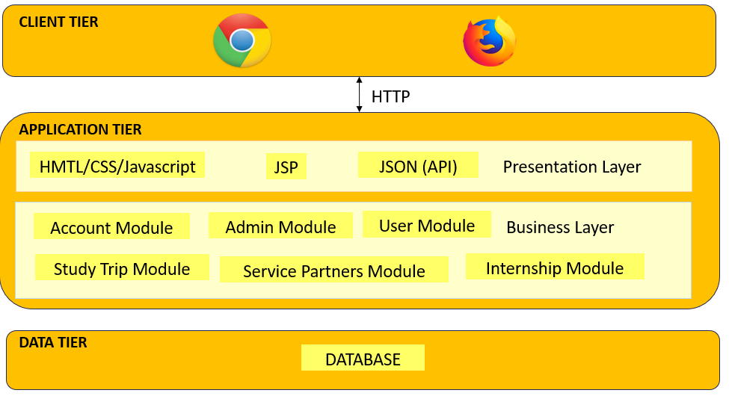

# Deployment Platform

Deployment platform is the location where the web application is hosted. In another word, it the environment that the web application is currently running on.

Currently, the web application that our group has built is running on Amazon Web Service (AWS) cloud platform.

Our group had also tried to deploy our web application to GoDaddy but it was unsuccessful. The reason might be because GoDaddy is running on a different operating system which is Linux, this might be the very reason that is causing our deployment to fail on GoDaddy. Please note that this is our group’s conjecture and we are not 100% sure of it due to the lack of time on our part to investigate the cause.

## Amazon Web Service Deployment Platform

Deployment link: <http://18.191.179.30/EpicFYPApp/login.jsp>

Deployment:

|  |  |
| --- | --- |
| URL | <http://127.0.0.1:8888/manager> |
| Password | uinyVTQ56YcZ |

AWS Account:

|  |  |
| --- | --- |
| Email/ Username | mediani.2015@sis.smu.edu.sg |
| Password | FYPPASS=1 |

Database:

|  |  |
| --- | --- |
| Link | http://127.0.0.1:8888/phpmyadmin/index.php |
| Username | root |
| Password | uinyVTQ56YcZ |
| Database name | epicdb |

## GoDaddy Deployment Platform

Deployment link: <http://testepicfyp.com/test/EpicFYPApp/web/index.html>

Domain name: testepicfyp.com

GoDaddy Account log in:

|  |  |
| --- | --- |
| Username | suhailah |
| Password | Ashrvf3003 |
| Pin | 3003 |
| Customer Number | 200743029 |

Filezilla File Transfer:

|  |  |
| --- | --- |
| Host | 148.66.137.35 |
| Username | hs2tfaalo02y |
| Password | Ashrvf3003! |
| Port | 21 |

During the Filezilla File Transfer, the application has been copied over from the local site (EpicFYPApp) to the remote site (public_html -> test).

# Git Repository

URL Link: <https://github.com/TheWhiteCollar/EPICJourney.git>

# Database

A database is a data structure that stores organized information.

The database that is currently in used is MySQL.

Currently, there is **13** tables in our database.

The following are the tables that are in our database:

* Admin
* Company
* Country Internship
* Country Trip
* Field of Study
* Interest
* Internship
* Internship Student
* Internship Student Status
* Payment
* Trip
* Trip Student
* User

# Users

There are 3 main group of users.

## Students, Graduates, Working Adults

Our primary users will be users who will utilize our web application to search and register for programmes offered by EPIC.

## EPIC Adminstrators

Our secondary users will be the administrators who are in charge of the managing the programmes and the people who registered for the programmes.

## EPIC Service Partners

Our secondary users will be the service partners who work closely with EPIC to run the programmes. They will utilize our system to more effectively collaborate with EPIC.

# User Guide

## Primary Users

### Creating an Account

Step 1: Click on the “Click here to sign up as User!”.



Step 2: Fill up all your personal details accordingly.

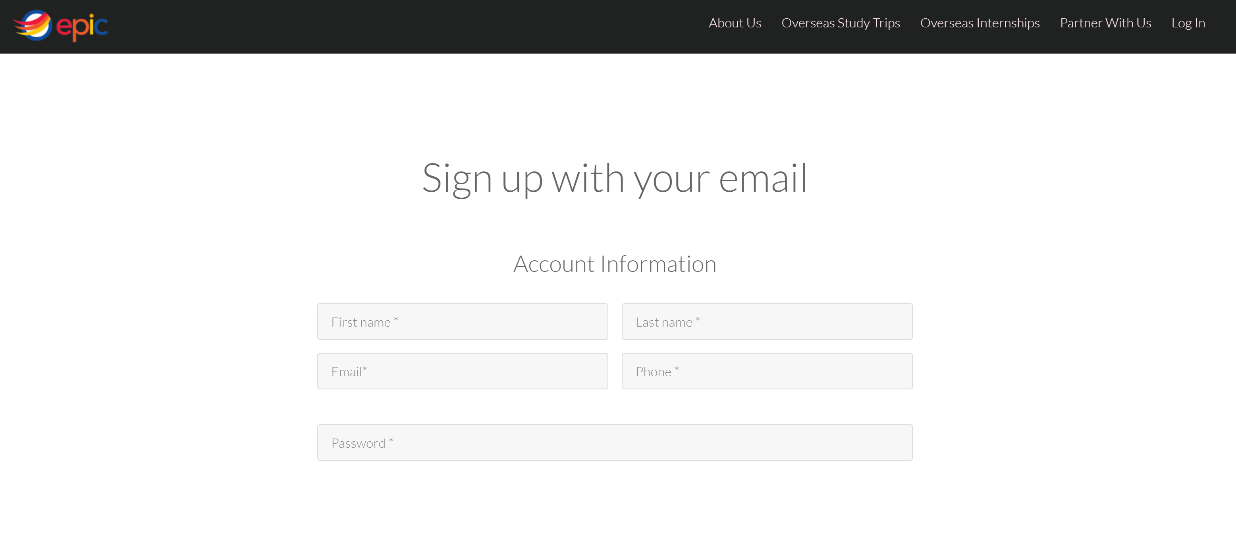

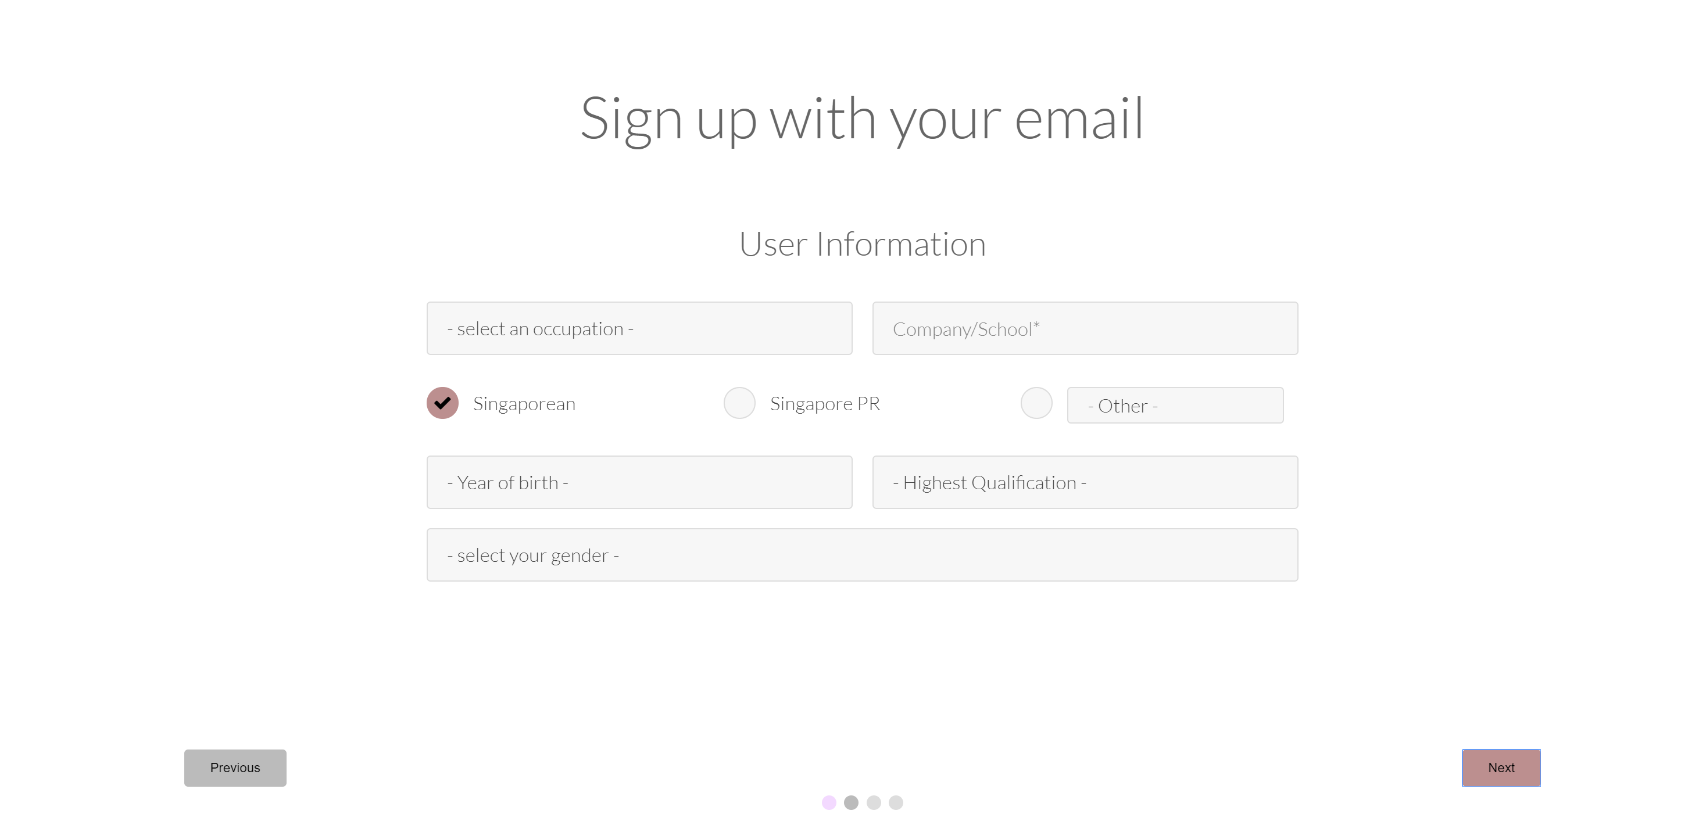

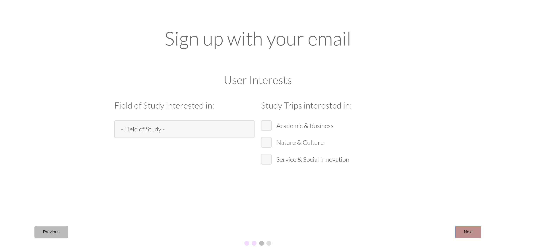

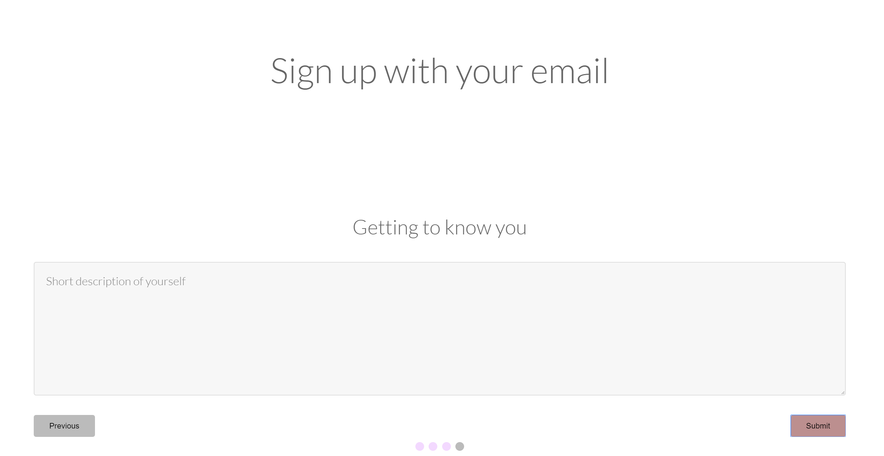

Step 3: Login to your account using your registered email and password.



Step 4: Select your choice, to either sign up for the study trip or join an internship.

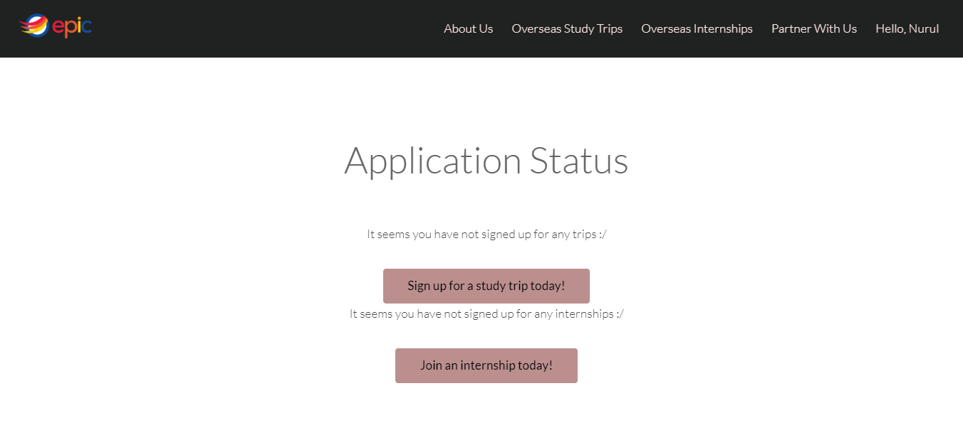

### Signing up for a Study Trip

Step 1: Click on the “Overseas Study Trip” in the top bar.

Step 2: Select a study trip of your choice

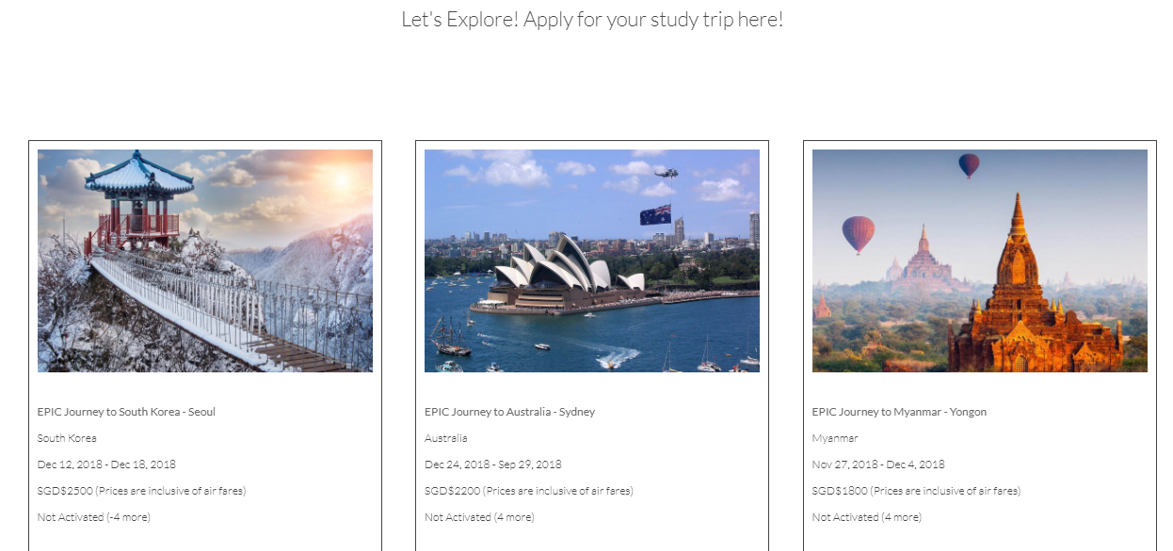

Step 3: Click on the “Apply” button to register for the study trip.

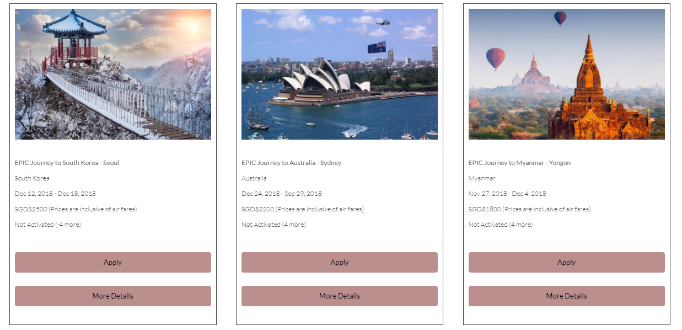

Step 4: View the Trip Details.

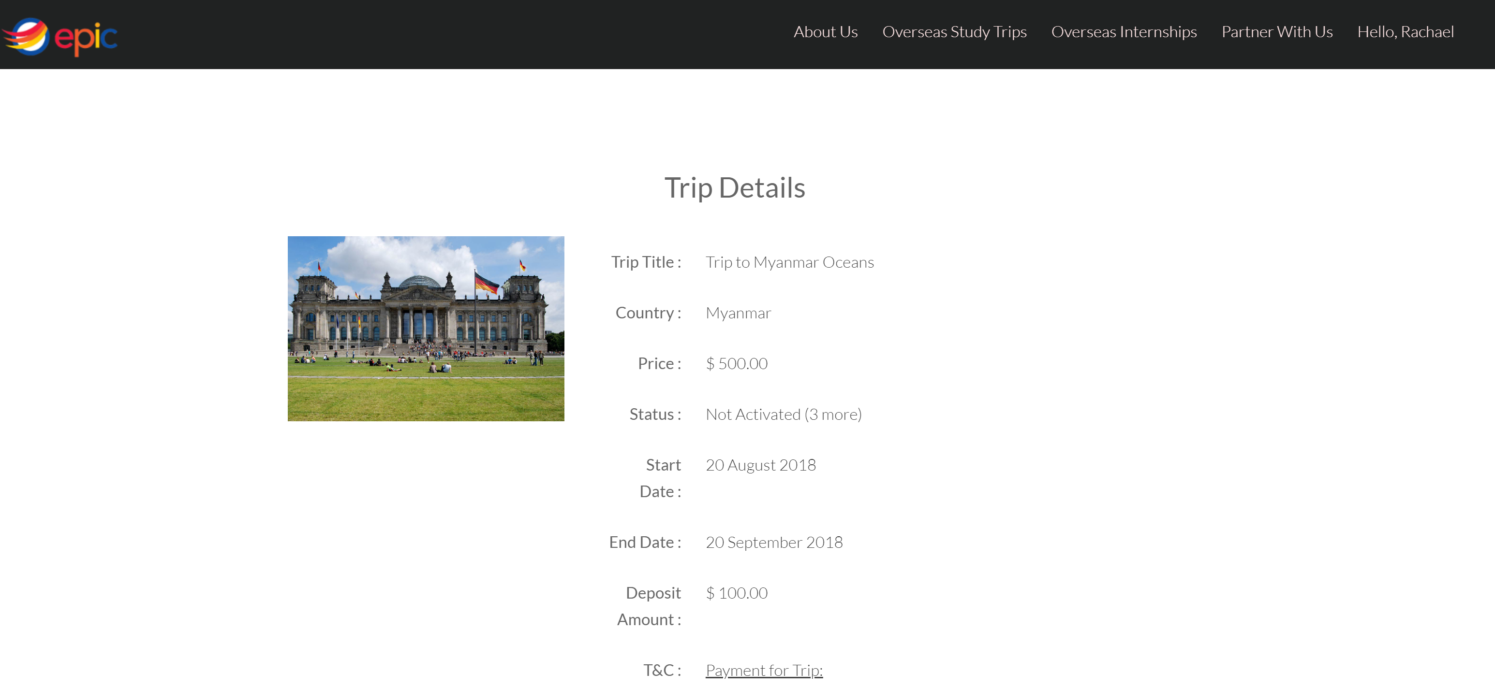

Step 5: Proceed to make deposit for the trip.

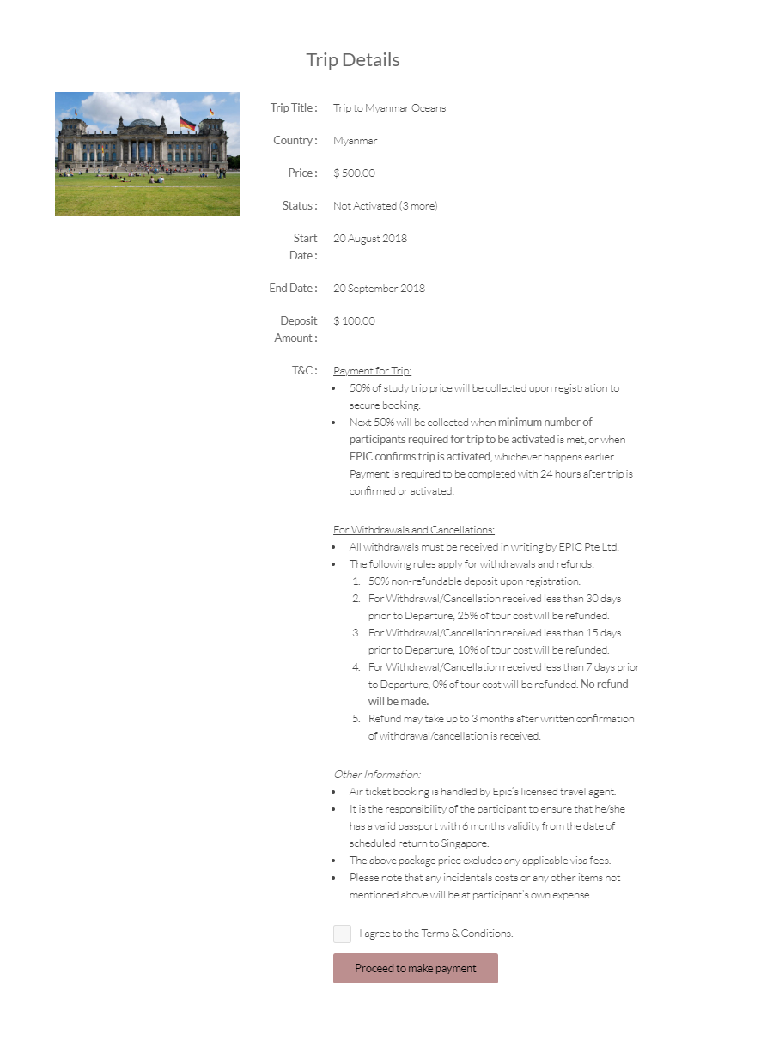

Step 6: Select your preferred payment method.

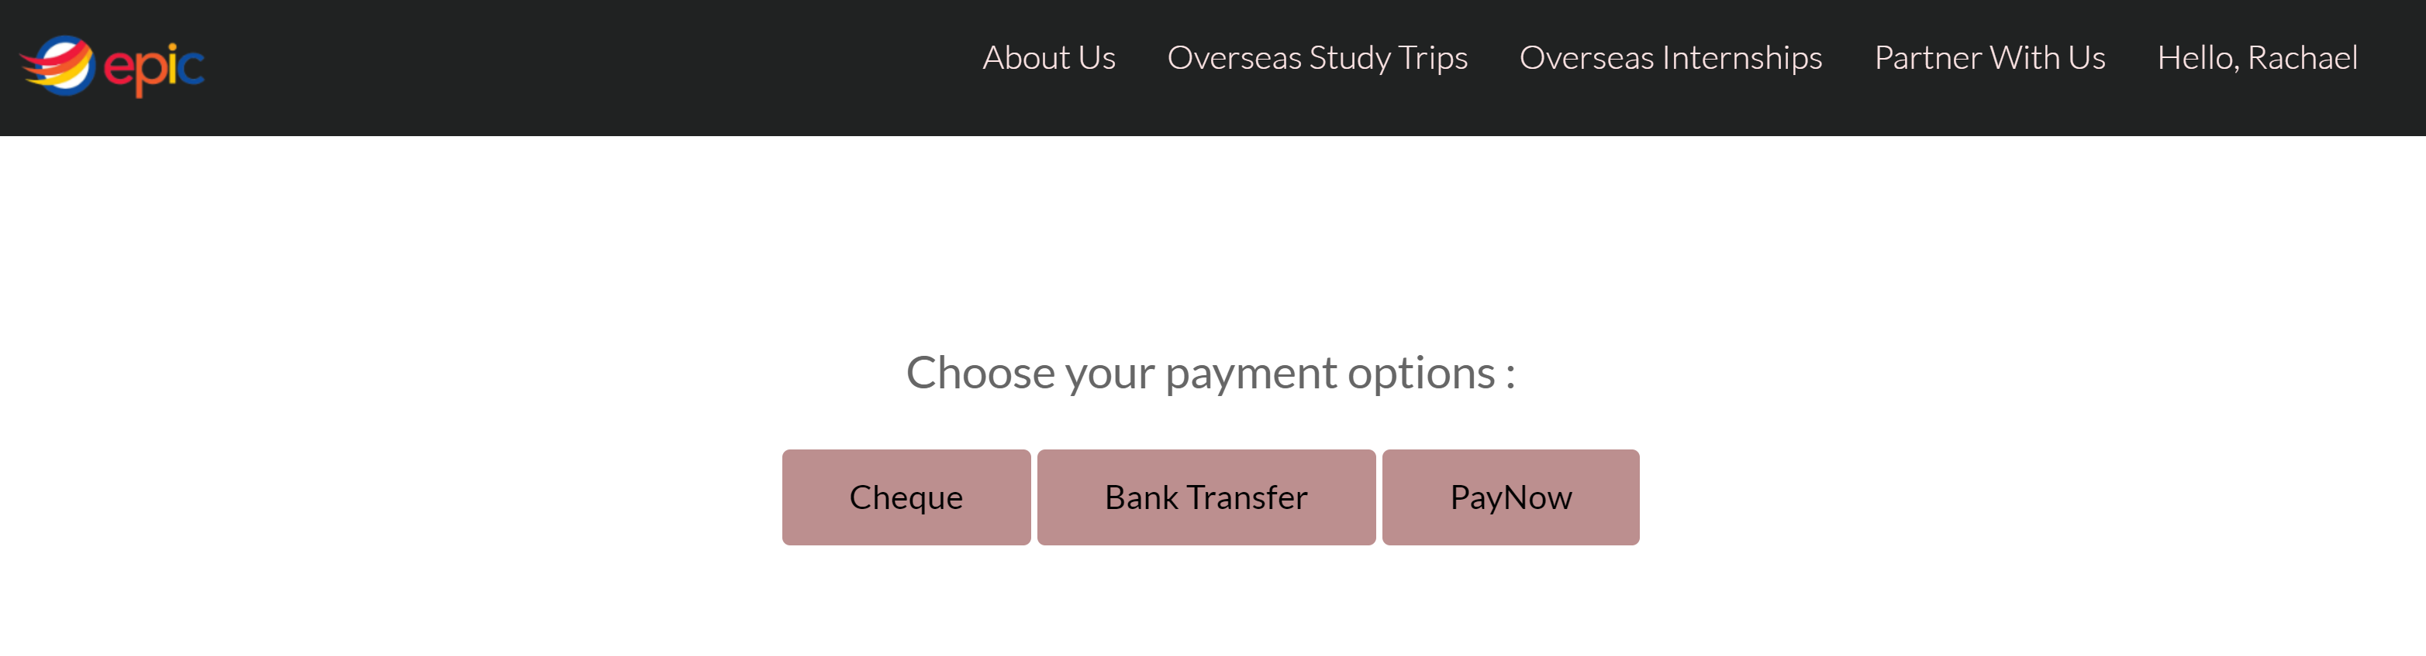

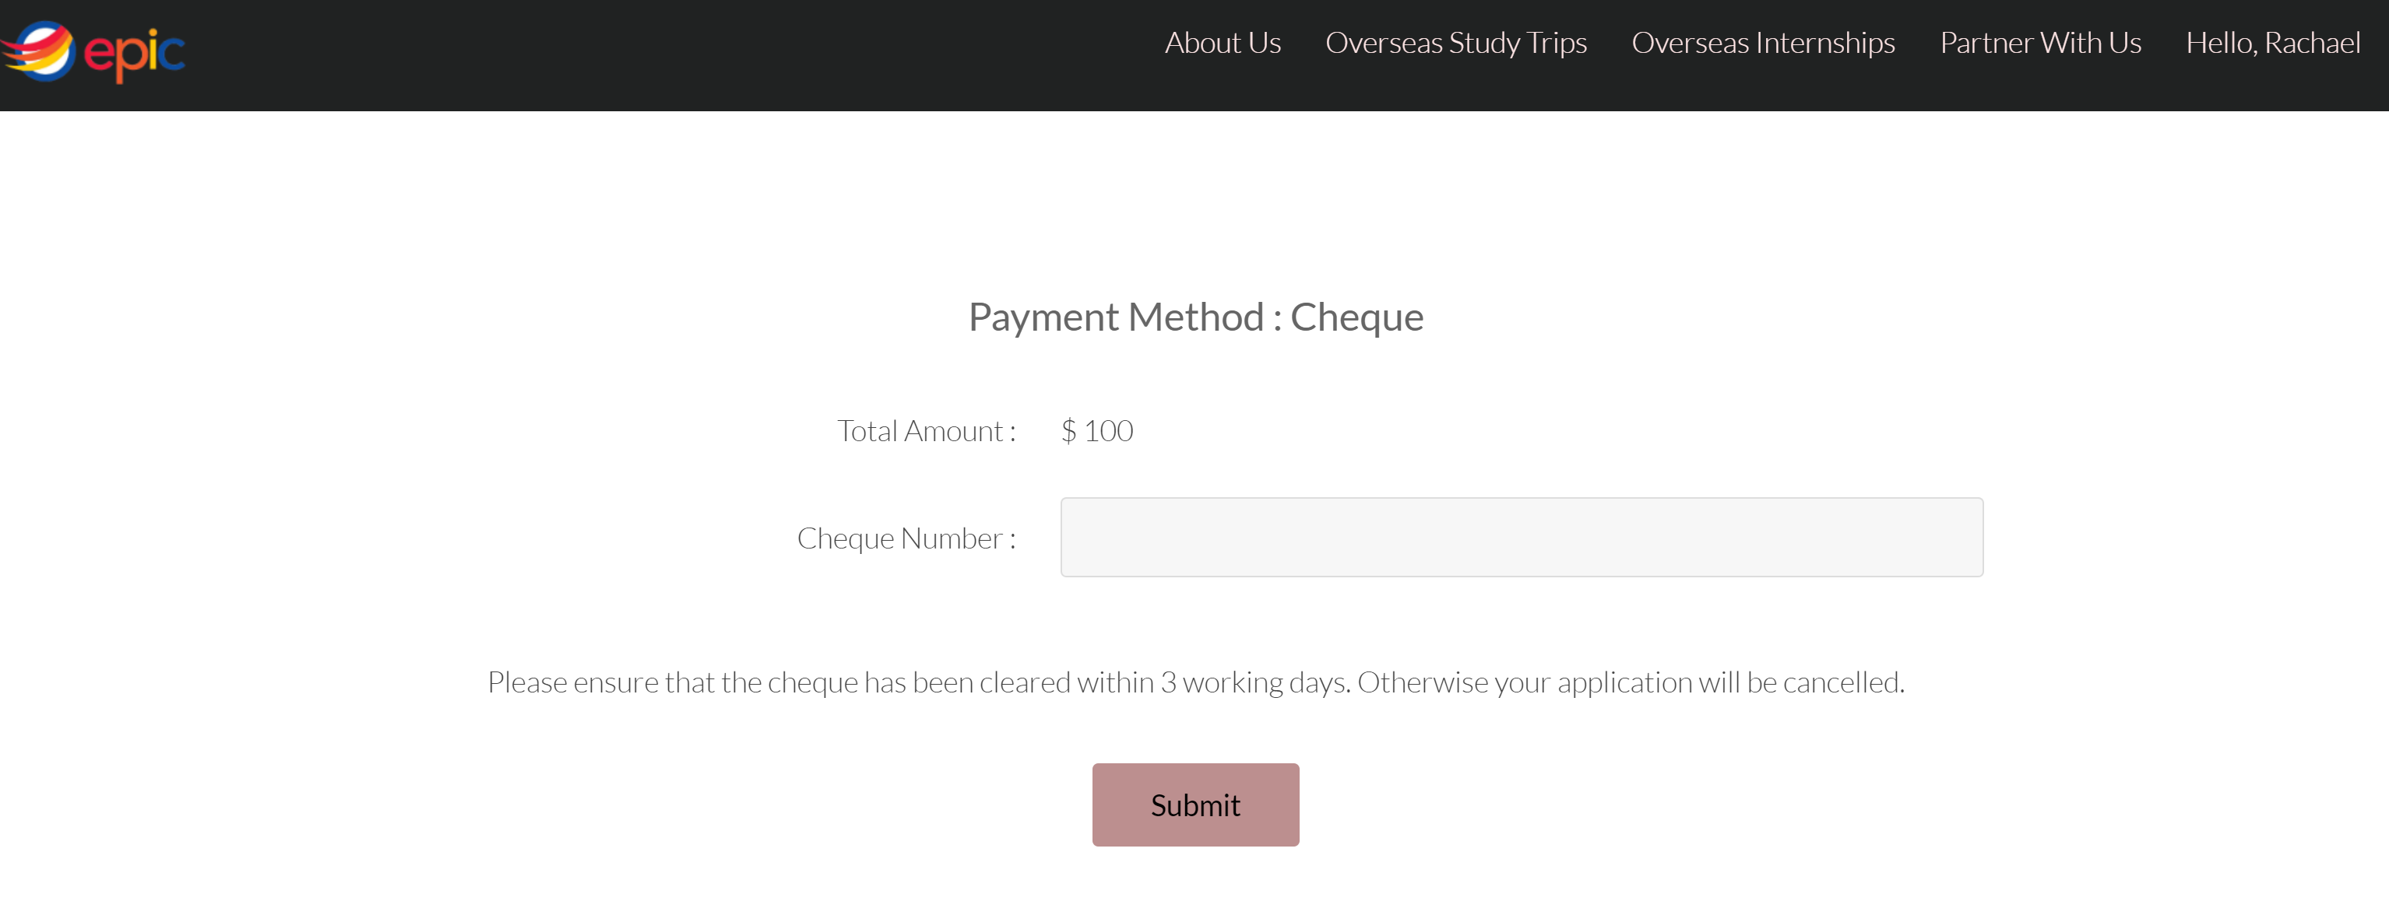

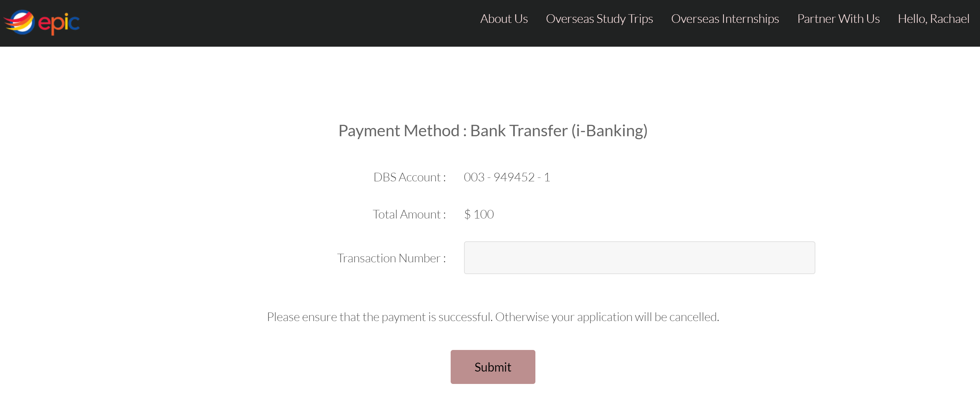

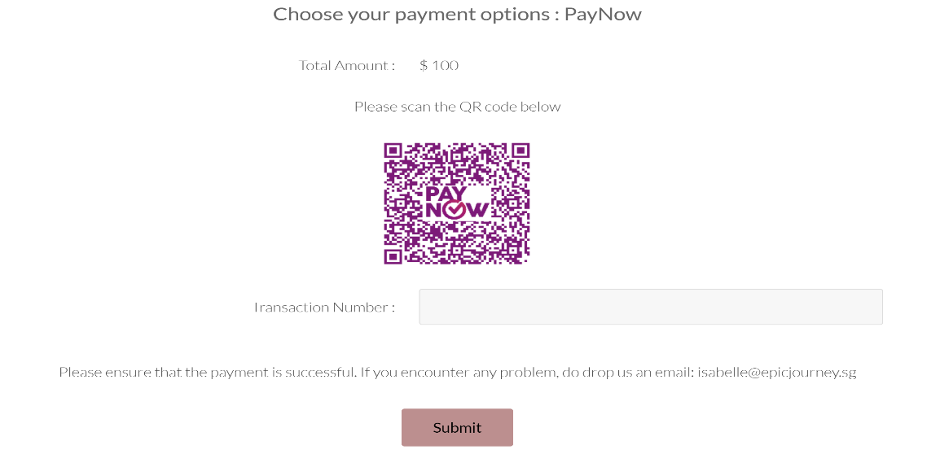

Step 7: Receive payment status.

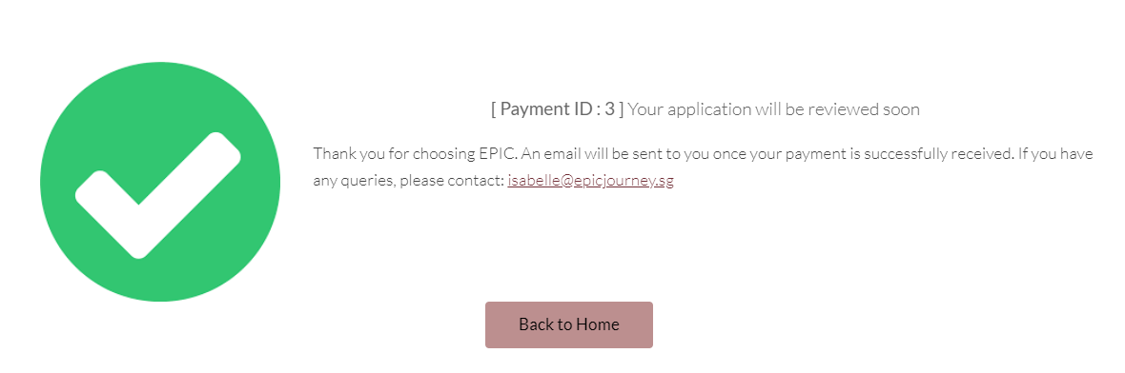

Deposit payment is received. Once trip is activated, proceed to make full payment.

### Signing up for an Internship

Step 1: Click on the “Overseas Internship” in the top bar.

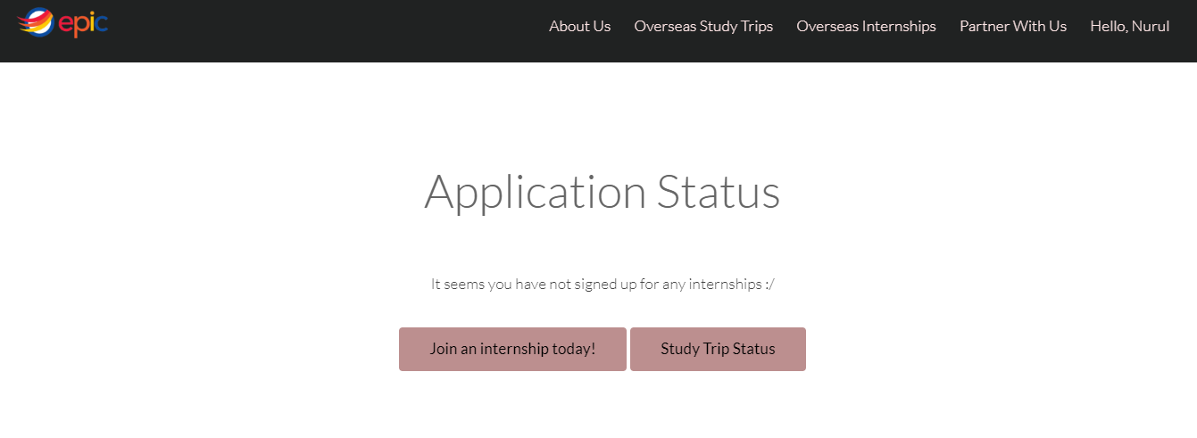

Step 2: Choose a continent that you prefer.



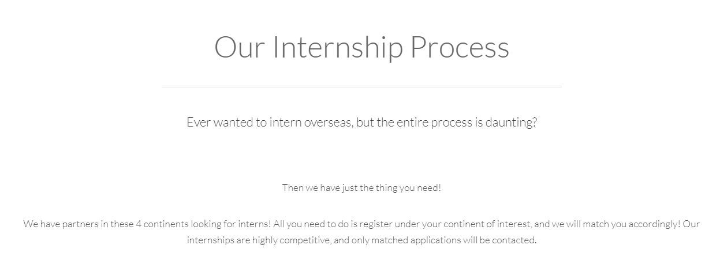

Step 3: Confirm your personal details and attach your resume.

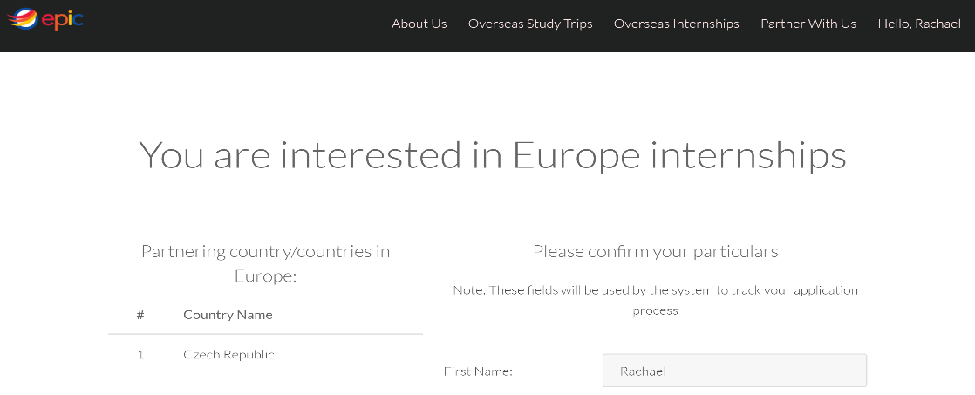

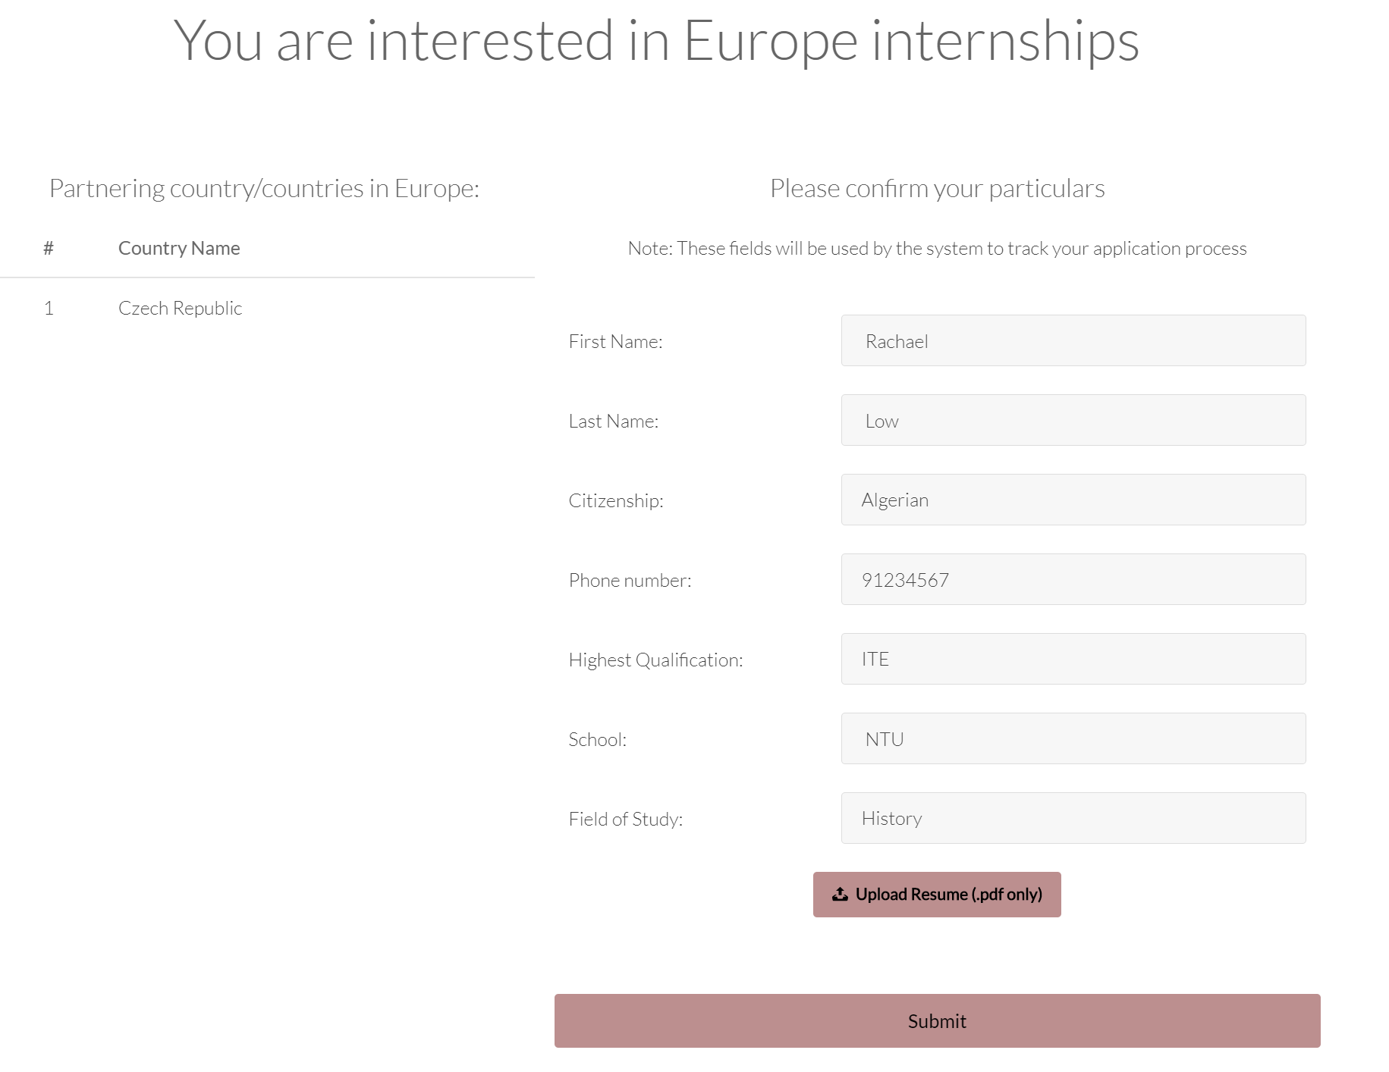

Step 4: Your interest has been noted.



## Secondary Users – ADMINS

### Log in as an admin

Step 1: Login to your account using the admin default username and password.

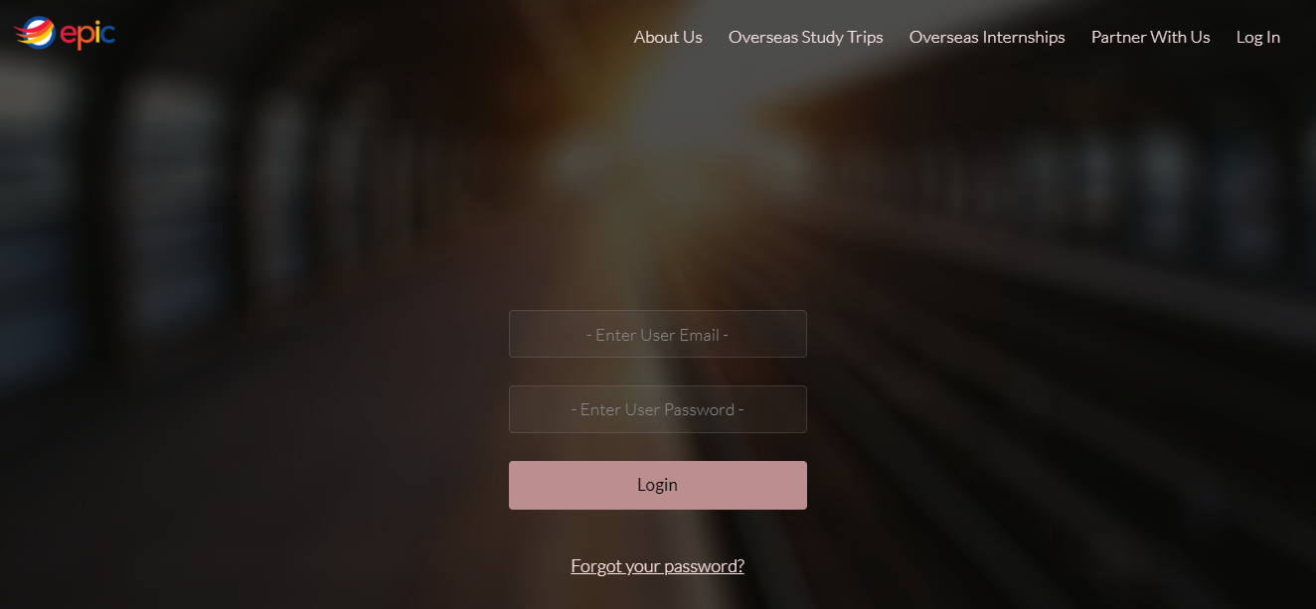

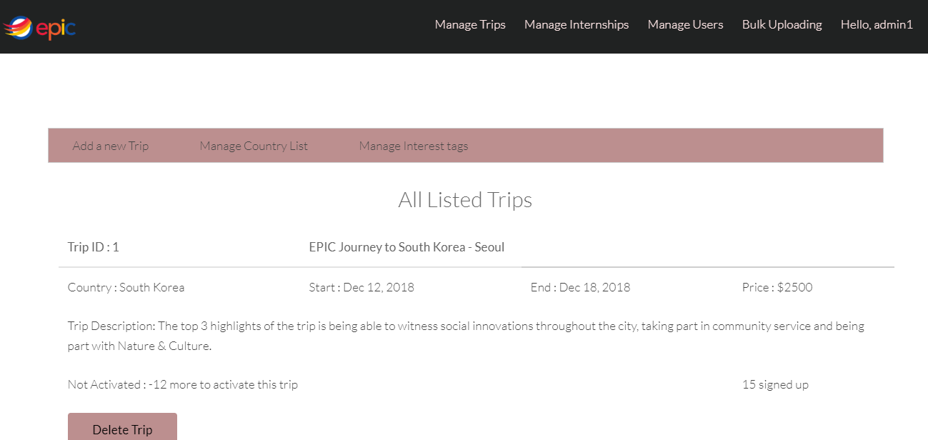

### Managing Study Trips

Step 1: Adding a new Study Trip

Manage Trips > Add a new Trip

Fill up the required fields and click on “Create a Trip” button.

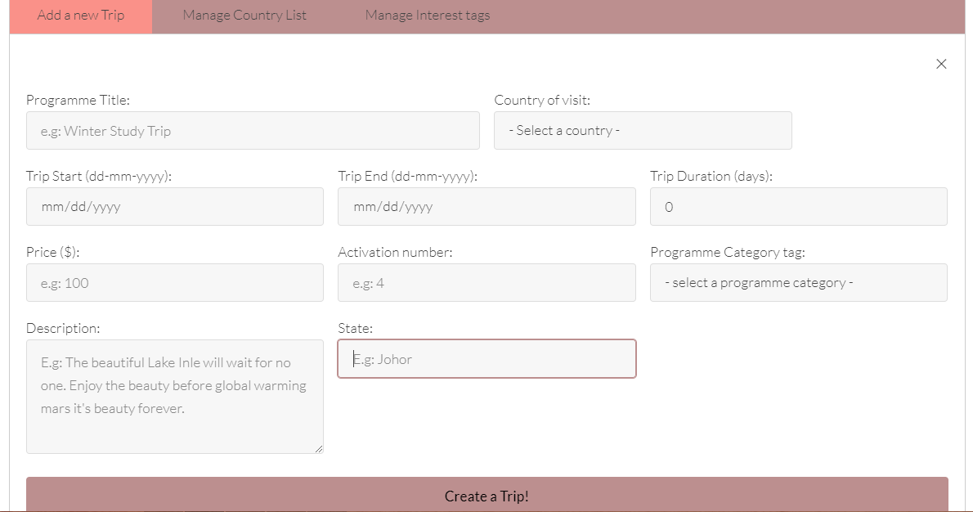

Step 2: Adding new countries to the list

Manage Trip > Manage Country List

Click on “Delete” to delete trips and add a new country if needed.

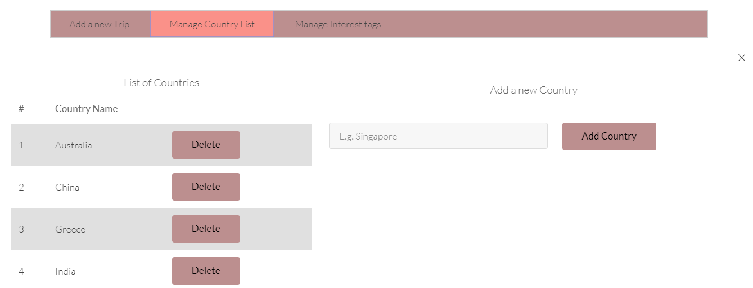

Step 3: Adding new interest to the list

Manage Trip > Manage Interest tags

Click on “Delete” to delete interest tags and add a new interest tag if needed.

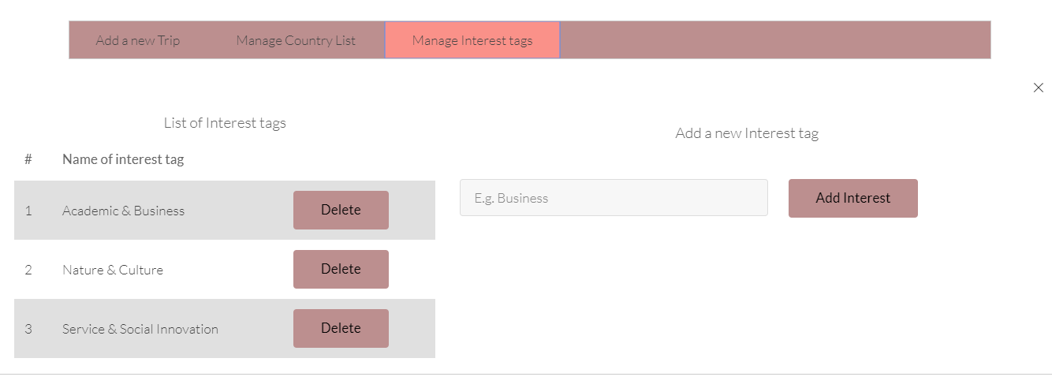

Step 4: Managing User Trip Applications

Manage Trips > User Trip Applications

Click on “View” button to view user details.

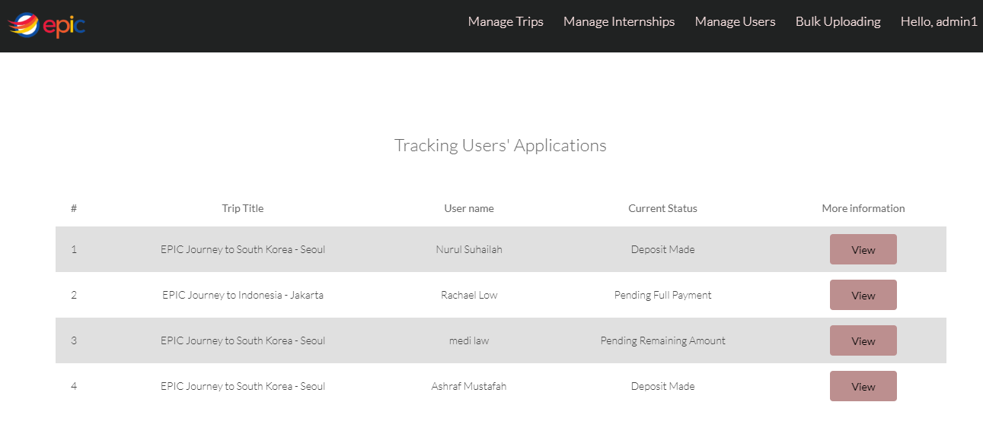

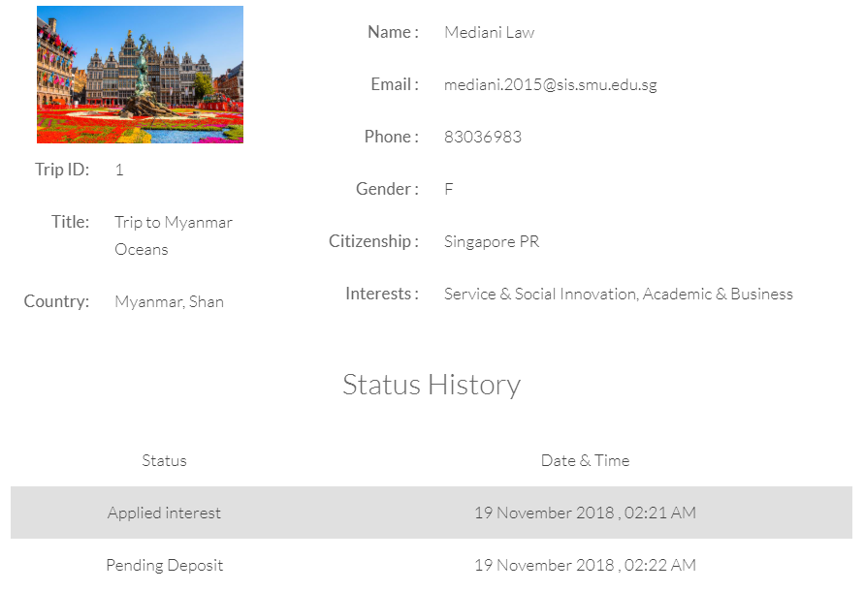

### Managing Internships

Step 1: Managing Partner Applications

Manage Internships > Partner Applications

Click on “View” button to view partner’s applications and “Delete” button to delete partner’s applications.

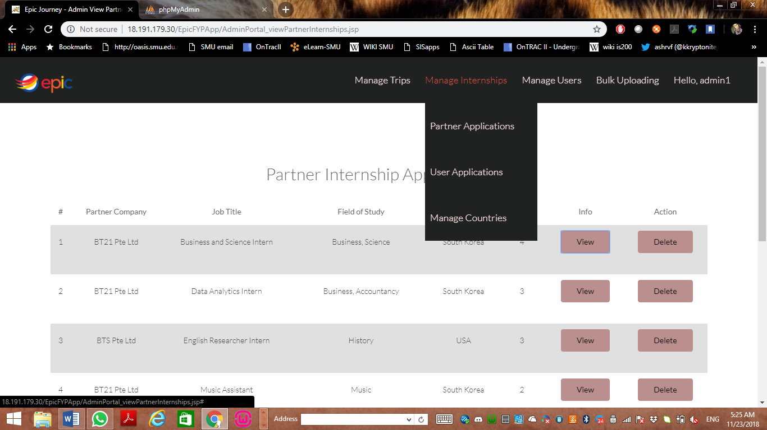

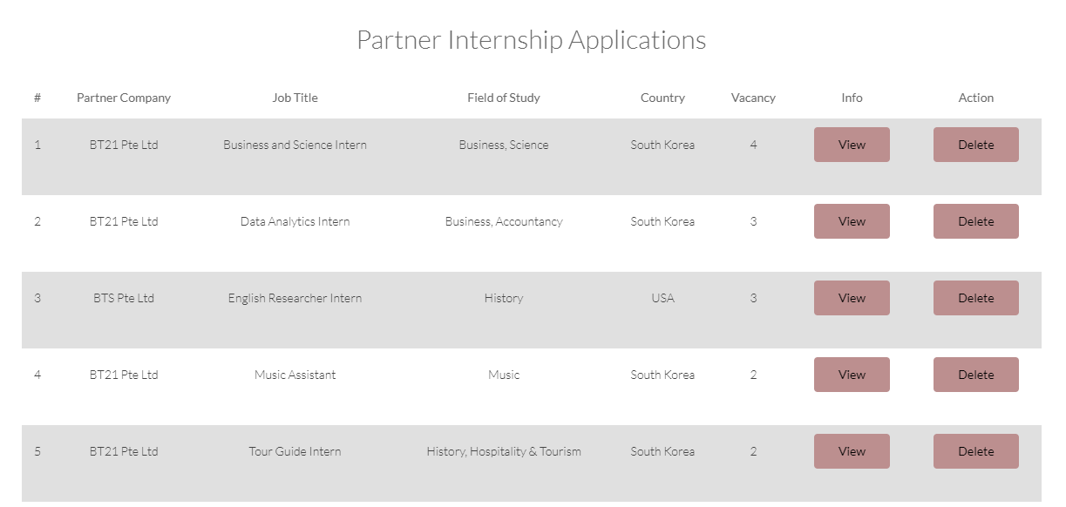

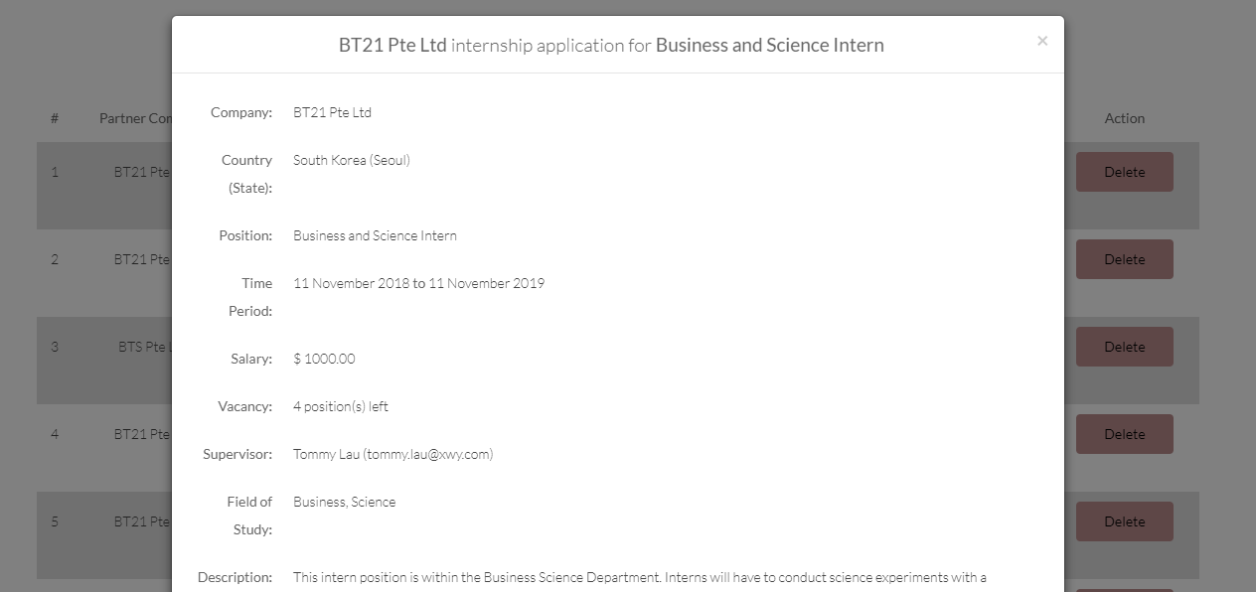

Step 2: Managing User Applications

Manage Internships > User Applications

Click on “Confirmed”, “Pending User Action”, “Pending Admin Action”, “Rejected” or “Cancelled” button.

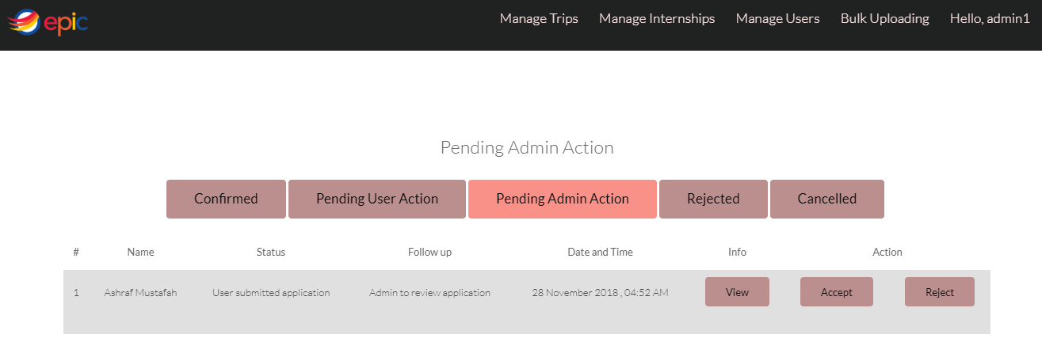

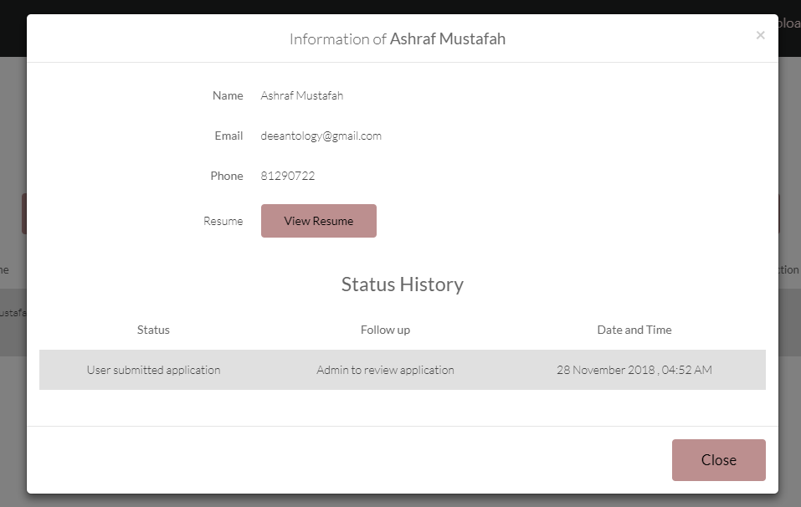

Step 3: Managing Countries List

Manage Internships > Manage Countries

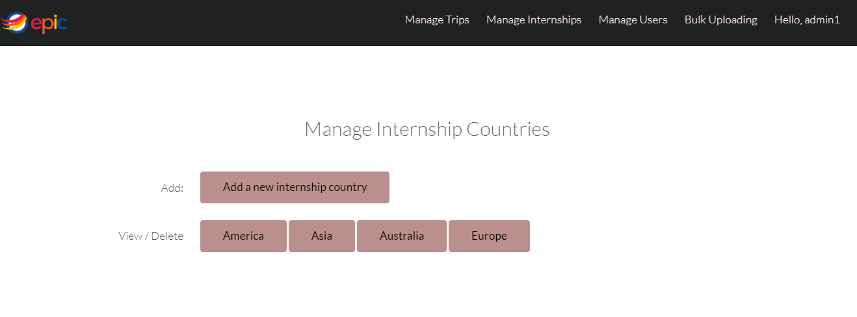

Click on “Add a new internship country” button to add new country.

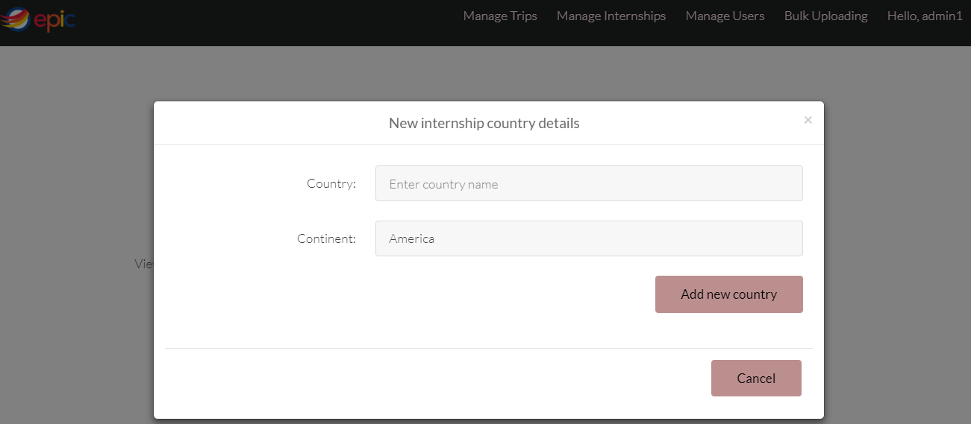

Click on the continent that you want to view or delete.

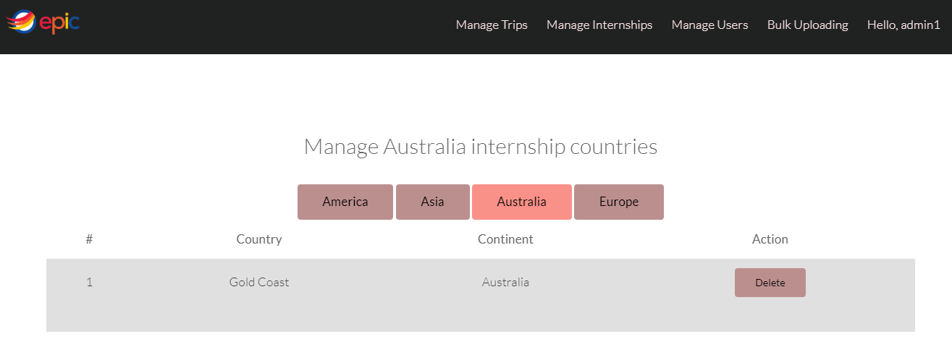

### Managing Users

Step 1: View primary users

Manage Users > View Students

Click on “View” button to view student’s information and click on “Delete” button to delete user.

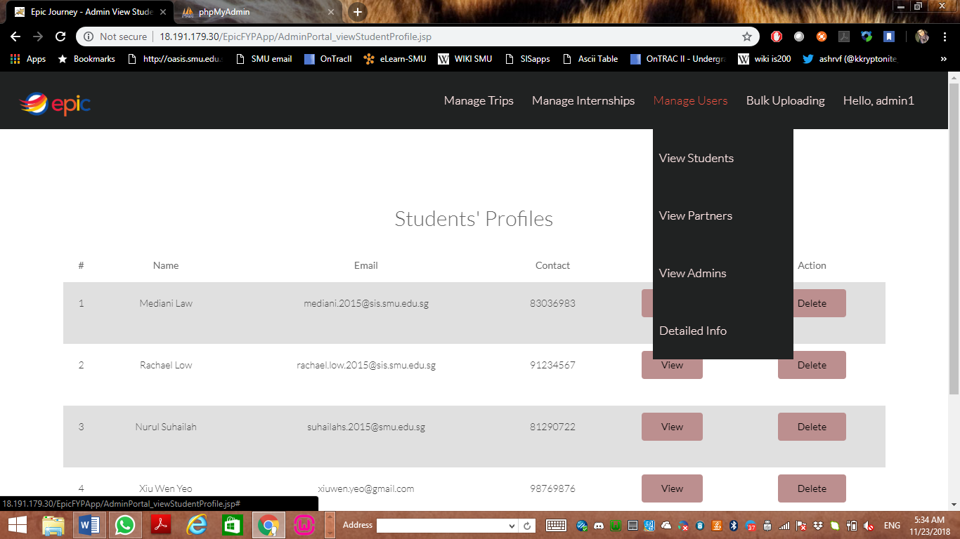

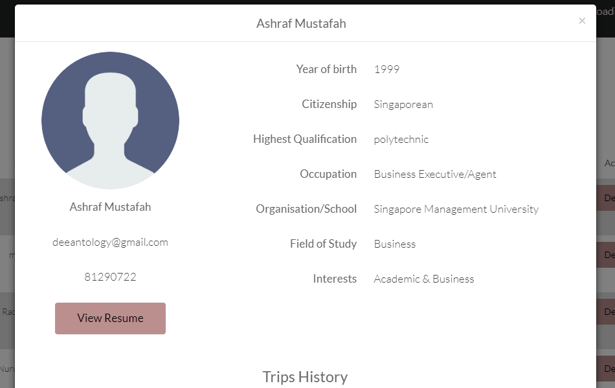

Step 2: View Service Partners

Manage Users > View Partners

Click on “View” button to view partner’s profile.

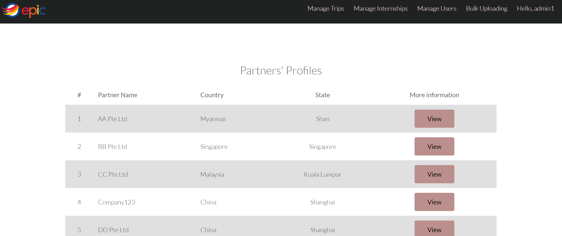

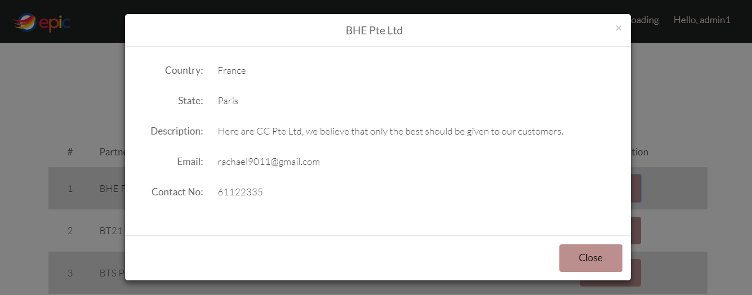

Step 3: View Admins

Manage Users > View Admins

Click on “Add New Admin” button to add new admin and click on “Delete” button to delete admin.

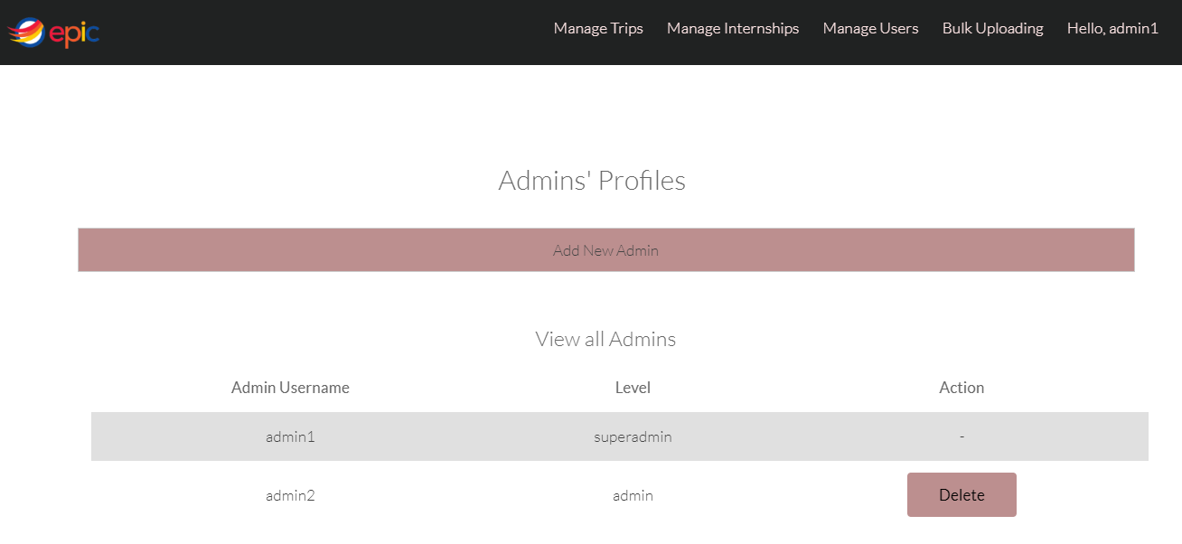

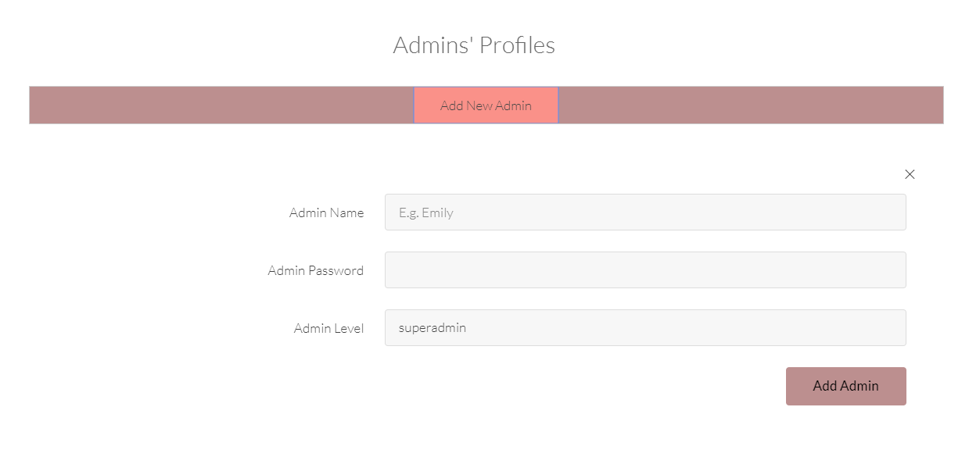

Step 4: Detailed information

Manage Users > Detailed Info

Click on “Save as PDF” button to save as PDF.

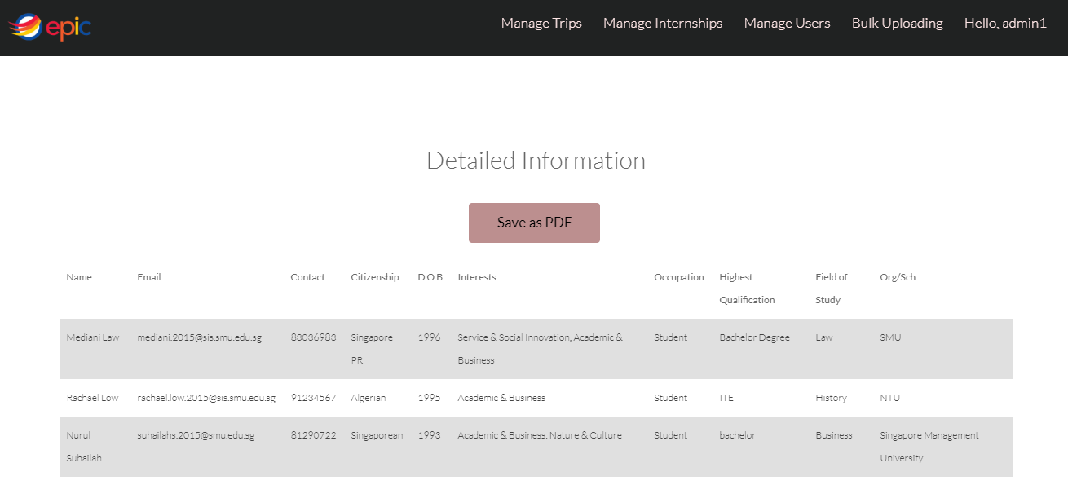

### Bulk Uploading

Click on the “Bulk Uploading” on the top bar.

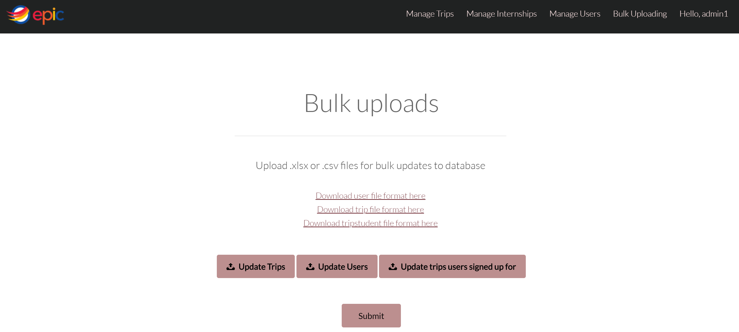

## Secondary Users – Service Partners

### Sign up as a Service Partner

Step 1: Click on the “Click here to sign up as Partner!”.

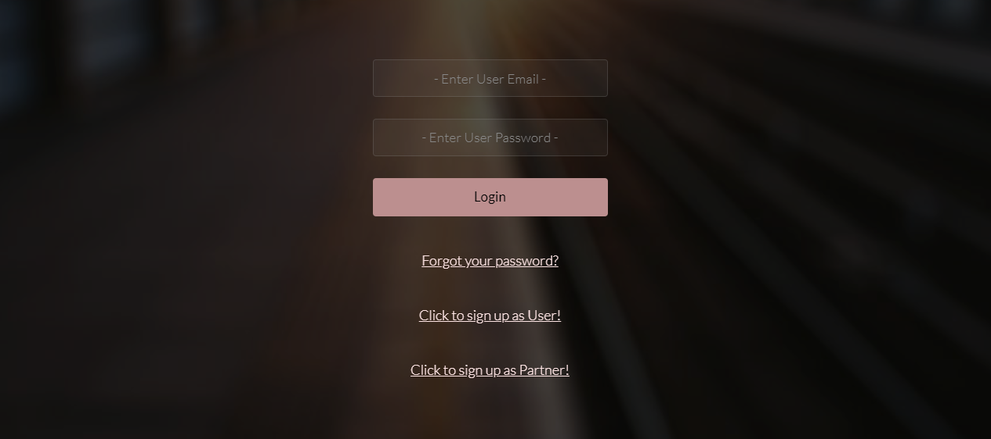

Step 2: Fill up all your personal details accordingly.

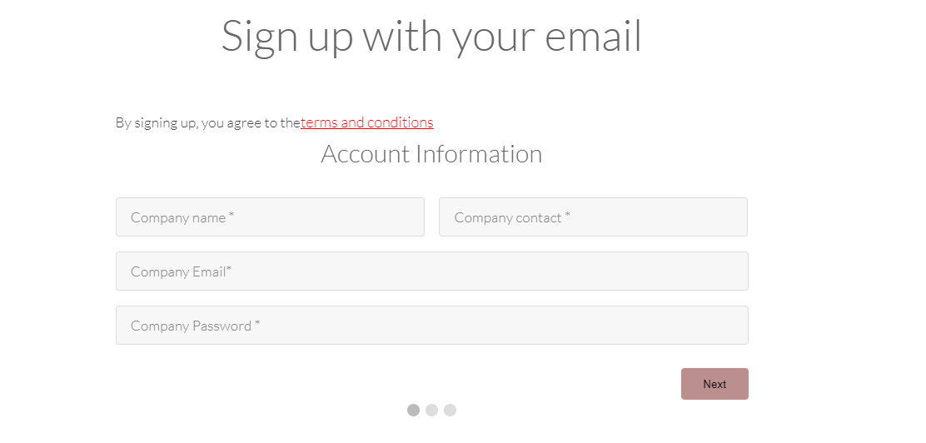

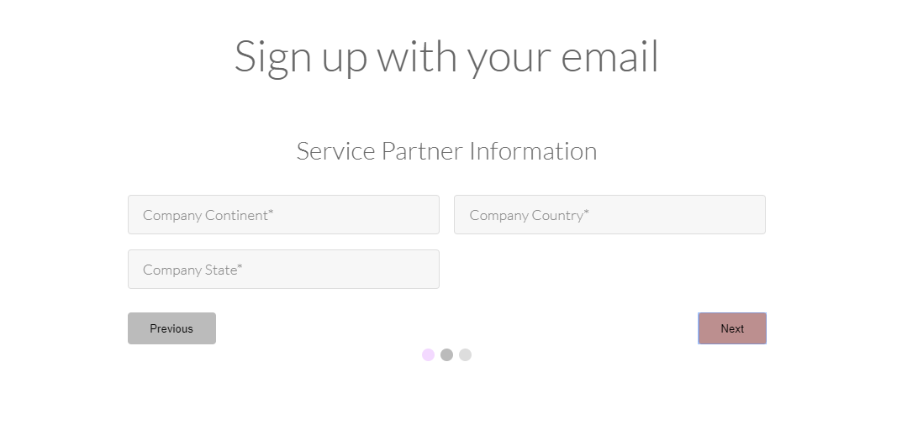

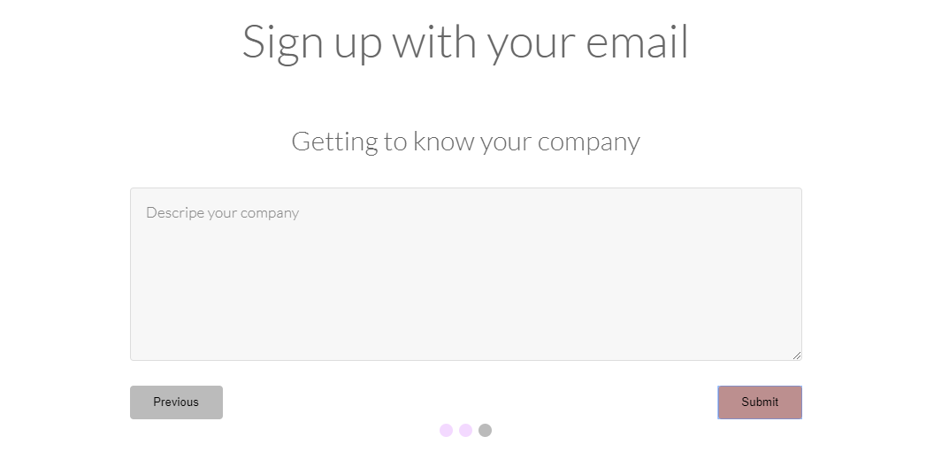

Step 3: Login to your account using your registered email and password.

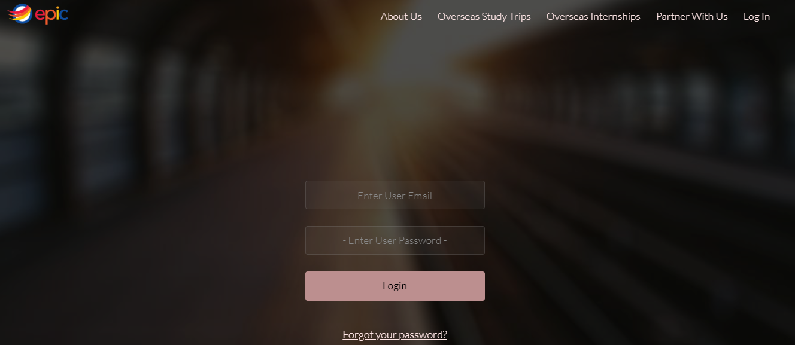

### Add a new Internship Posting

Step 1: Click on the “Add New Internship” at the top bar. Fill up all the relevant information and click on the “Create an Internship!” button.

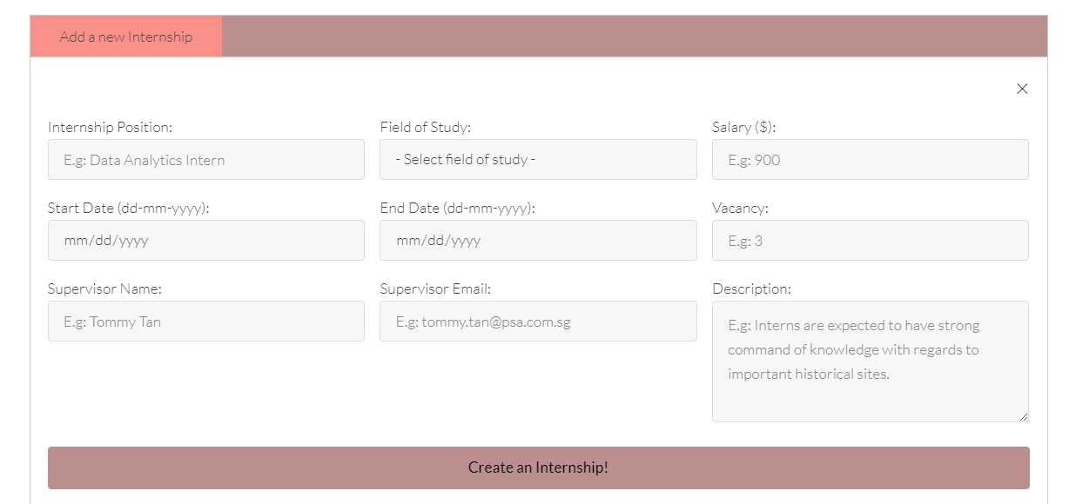

### Manage Internship Posting Status

Step 1: Click on the “Manage Internship” at the top bar.

Click on “Delete” button to delete internships.

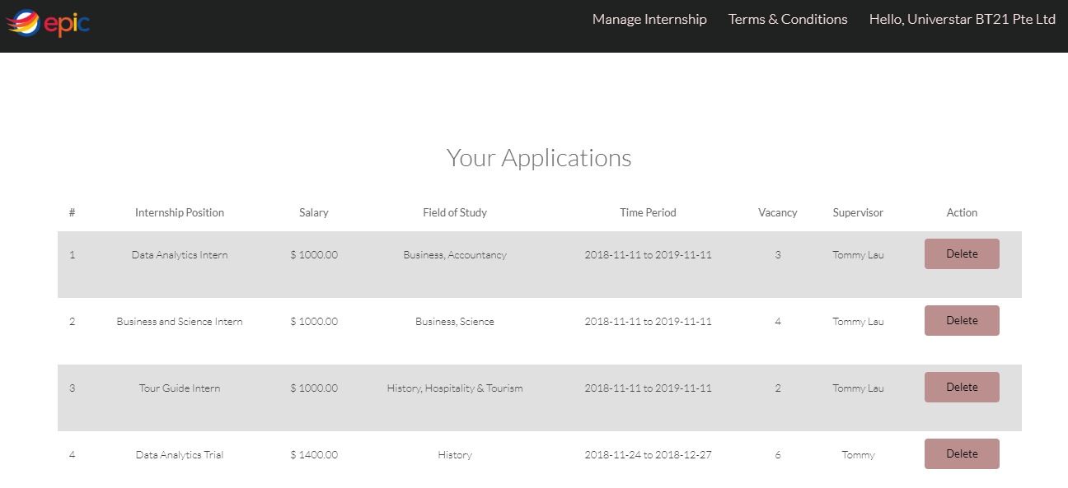

### View Terms and Conditions

Step 1: Click on the “Terms and Conditions” at the top bar.

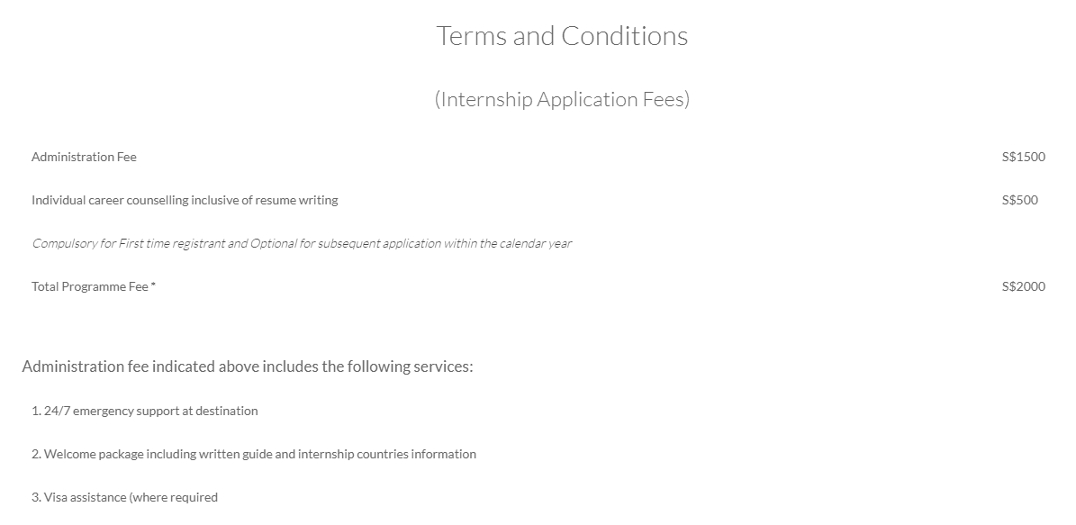

--- END OF THIS DOCUMENT ---